

*Writing Test…*

1. What’s your nickname?
2. What do you do in your free time?
3. What’s your favorite time of the year?
4. Have you ever been to Cox’s Bazar?
5. What’s your favorite sport?
6. When do you get up from bed?
7. When do you go to sleep?
8. When do you take physical exercise?
9. When do you go out for walking?
10. Do you love travelling? Why? 20 -30 words
11. Why do you think English is a necessary language to learn? 20 -30 words
12. What are the most important festivals in your country?

20 -30 words

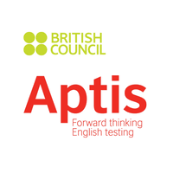

**prepared and provided by Redwan Ahmed Rony APTIS Trainer and course Supervisor.**

**#ICT Division ,BD #BRITISH Council**

Tongue twist

Betty brought a butter

The butter was bitter

So she bought a better butter

To make the bitter butter better.